**FUNDAMENTALS TO COMPUTER PROGRAMMING**

**Name:** Hassan Shahzad

**Class:** BS CS 7C

**CMS ID:** 211798

**TASK 01**

**1.**

#include <stdlib.h>

#include <stdio.h>

int main(void)

{

// Declaring Integers

int

// Declaring variable name = cars

cars

// Declaring variable name = drivers

, drivers

// Declaring variable name = passengers

, passengers

// Declaring variable name = cars_not_driven

, cars_not_driven

// Declaring variable name = cars_driven

, cars_driven;

// Declaring floating point numbers

float

// Declaring variable name = space_in_a_car

space_in_a_car

// Declaring variable name = carpool_capacity

, carpool_capacity

// Declaring variable name = average_passengers_per_car

, average_passengers_per_car;

// Assigning value to cars

cars = 100;

// Assigning value to space_in_a_car

space_in_a_car = 4.0;

// Assigning value to drivers

drivers = 30;

// Assigning value to passengers

passengers = 90;

// Formula to calculate cars_not_driven

cars_not_driven = cars - drivers;

// Declaring cars_driven = drivers

cars_driven = drivers;

// Formula to calculate carpool_capacity

carpool_capacity = cars_driven * space_in_a_car;

// Formula to calculate average_passengers_per_car

average_passengers_per_car = passengers / cars_driven;

// Printing THERE ARE 100 CARS AVAIALABLE

printf("There are %d cars available.\n", cars);

// Printing THERE ARE ONLY 30 DRIVERS AVAILABLE

printf("There are only %d drivers available.\n", drivers);

// Printing THERE WILL BE 70 EMPTY CARS TODAY

printf("There will be %d empty cars today.\n", cars_not_driven);

// Printing WE CAN TRANSPORT 120.0 PEOPLE TODAY

printf("We can transport %.1f people today.\n", carpool_capacity);

// Printing WE HAVE 90 TO CARPOOL TODAY

printf("We have %d to carpool today.\n", passengers);

// Printing WE NEED TO PUT ABOUT 3.0 IN EACH CAR

printf("We need to put about %.1f in each car.\n", average_passengers_per_car);

return EXIT_SUCCESS;

}

**Output:**

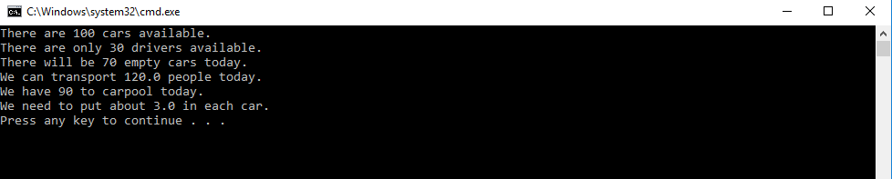

**2. Floating Point:**

It is used to represent decimal numbers.

**3.**

No, it’s not necessary we can simply represent 4.0 by 4 because both are same values. The program runs without an error.

**TASK 02**

#include <stdlib.h>

#include <stdio.h>

int main(void)

{

char Name[] = "Muaz Hashmi";

char Eyes[] = "Brown";

char Teeth[] = "White";

char Hair[] = "Black";

int Age = 30; // not a lie

int Height = 70; // inches

int Weight = 170; // lbs

float height_cm = Height * 2.54;

float weight_cm = Weight * 0.453;

printf("Let's talk about %s.\n", Name);

printf("He's %d (or %f cm) inches tall.\n", Height, height_cm );

printf("He's %d ( or %f kg) pounds heavy.\n", Weight, weight_cm);

printf("Actually , that's not too heavy.\n");

printf("He's got %s eyes and %s hair.\n", Eyes, Hair);

printf("His teeth are usually %s depending on the coffee.\n", Teeth);

// This line is tricky; try to get it exactly right.

printf("If I add %d, %d, and %d I get %d.\n"

, Age, Height, Weight

, (Age + Height + Weight));

return EXIT_SUCCESS;

}

**Output:**

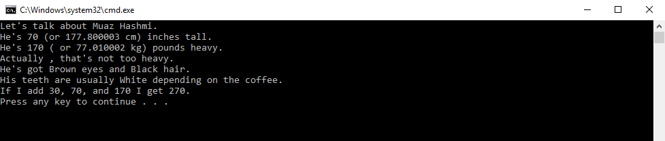

**TASK 03**

#include <stdio.h>

#include <math.h>

int main()

{

int x = 3;

float y = 2.71828;

char z[] = " Computer Science ";

printf(" This is Lab %d\n", x);

printf(" e is close to %f\n", y);

printf(" I am learning a bit about %s\n", z);

return 0;

}

**Output:**

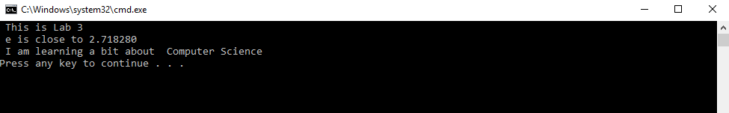

**TASK 04:**

#include <stdio.h>

#include <math.h>

int main()

{

int x = 2021;

char z[] = " Hassan Shahzad ";

printf("My name is %s",z);

printf(" and I'll graduate in %d\n", x);

return 0;

}

**Output:**



**TASK 05:**

int main()

{

char sub1[] = "Fundamentals of Computer Pogramming";

char sub2[] = "Fundamentals of ICT";

char sub3[] = "Discrete Maths";

char sub4[] = "Calculus-1";

char sub5[] = "Islamic Studies";

char sub6[] = "Communication and Impersonal Skills";

char t1[] = "Mr.Anis";

char t2[] = "Mr.Jaudat";

char t3[] = "Mr.Usman";

char t4[] = "Mr. Ramzan";

char t5[] = "Ms. TBA";

char t6[] = "Ms.Maria";

printf("+----------------------------------------------------------------+\n");

printf("| 1 | %s | %s |\n", sub1, t1);

printf("| 2 | %s | %s |\n", sub2, t2);

printf("| 3 | %s | %s |\n", sub3, t3);

printf("| 4 | %s | %s |\n", sub4, t4);

printf("| 5 | %s | %s |\n", sub5, t5);

printf("| 6 | %s | %s | \n", sub6, t6);

printf("+----------------------------------------------------------------+\n");

}

**Output:**

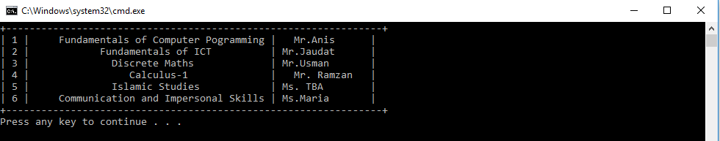

**Brief Explanantion:** In this lab we have used print statement to print strings, floating point numbers and variables.

**The END**

